Journal Club: How to set up an outpatient JC
Updated 5/11/2020: Brian Locke
- Choose a clinical practice guideline (CPG) = topic area. JAMA Guideline Clinical Synopsis. Annals of Internal Medicine, and High profile specialty journals (JACC for ACC/AHA, JAMA for USPSTF, AJRCC for Pulm, etc.)’s website are good places to look for ideas. The best choices are:
  - -primarily applicable to outpatient medicine
  - –Relatively recently released
  - -Avoid PEAC module topics
  - -Does NOT have to be “good” – deficiencies in the guideline (weak recommendations, don’t provide actionable information, unclear rating or assessment of literature, etc.) can make good points of discussion
  - IDEALLY (but not required) they will have a secondary literature synopses, such as a JAMA Guideline Clinical Synopsis article or a “Summarizing the evidence” release (e.g. the ACC/AHA guidelines) that make it more digestible for the residents.
    - If giving the entire guideline to the residents – you’ll have to be careful to keep them focused on a few points for discussion, as many of the guidelines are very long
  - The UU IM Facilitator template has common discussion points about CPGs that can guide discussion – it’s good to mix in some points about the guideline itself (e.g. how they present strength of evidence vs strength of effect, if they give information needed to advise patients, etc.) and some about generalizability (e.g. do they have a target population? Are there issues with systemic implementation… e.g. as quality metrics for reimbursement or standards for litigation?)

- Choose a paper
  - The best papers to highlight are ones that either
    - Led to a new recommendation in the guideline (e.g. when compared to past versions of the same guideline)
    - Addresses a gap in the guideline (either if the
  - Papers can be any study design: Templates to guide housestaff in analyzing the articles already exist for cohort studies, RCT, part way through meta-analysis and Clinical Decision Rules. If others, we’ll have to make a template.
  - The UU IM Facilitator template has common discussion points for the various study designs that can serve as areas to focus on during analysis. Definitely not an exhaustive list and not universally applicable to all studies.. so consider which points are most interesting for a given article.

- Create a patient scenario to frame the discussion
  - The goal with the patient scenario is to frame discussion in a way that…
    - Highlights issues with external validity (aka generalizability) of the guidelines and studies – so it’s best to have the patient not neatly fit in the inclusion criteria or the study (or target population of the guideline)
    - Brings up areas where there is some tradeoff (e.g. expensive test that may be in the best interest of an individual patient but not society… or a medical case where patients values/preference might determine if the recommendation makes sense to follow). Think of it like a bad test question: ideal = no perfect answer
      - Example: ACC/AHA Lipid guidelines say consider CAC scoring for ASCVD 7.5+% with weak recommendation. Article on performance of CAC score. -> pt w/ 9% 10y risk and hesitant about statin, what would you do? As scenario.
    - The article should weigh in on the considerations that the question brings up.
Summary: try to craft the scenario so that step 4,5, and 6 are required – this is where the interesting discussion and learning occur (from Ann Intern Med. 2020;172:599-603. doi:10.7326/M19-1941) | Consider crafting the scenario in such a way where the patient will be expected (based on our prior knowledge of their illness[es], membership in relevant subgroup) to have a greater or lesser response than the average of everyone in the trial (this is termed heterogeneity of treatment effect)
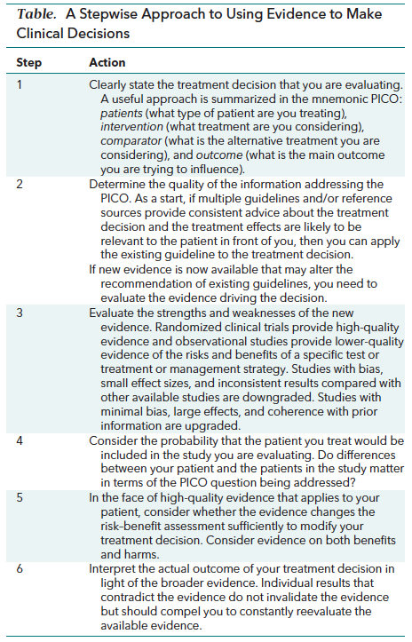 | 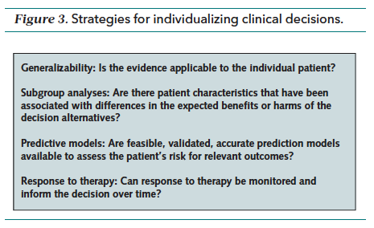

Email the residents on ACVA, +1, Non-IM, Addiction and interested attendings. Geri and MSK can also come in lieu of coming on +1 wk:
- Attach the templates that go along with the study type and the UU IM Template CPG
- Attach the article
- Attach the synopses to the guideline (+ a link to the full guideline for interested) if available, or attach the guideline itself with instructions about which area to focus.
- Assign 1 housestaff (I usually did a resident – but not required) to present the guideline and 1 resident to present the article. I prompted them with the idea that a.) we’re trying to synthesize down the article to the smallest useful summary – which is a skill, and b.) Presenting the answers to the critique template gives adequate depth for our conversation. (esp important to emphasize this to CPG presenter – could potentially go way down the rabbit hole)
- Try to send email by Friday before
Running the session
- Have Karen call in to Einstein Bagels on 1300e to pick up Bagels at 6:30-6:45. 2 baker’s dozen if it’s a large cohort, 1 if small. Same for coffee carafes. Better to err on the side of more food, since the VA is a desert. Ikea shopping bag or similar helpful for carrying it all in from the parking lot.
- Start 7:30. Spend <5 minutes introducing the format as people get introduced. The order that seemed to work best was: CPG presentation, discussion of the CPG (together ~15 minutes), read the case and discuss what –if anything – guideline recommends (5 minutes), then 15-20 minutes presenting article – with discussion of it’s barring to the case.
- Make sure to get the IHC cont clinic folks on the road by 7:15.

EXAMPLE EMAIL TEMPLATE:
Subj: __/__ Journal Club: ____ Guideline
Hello Everyone- Here are the details on next weeks Journal Club!

We’ll be having journal club this THURSDAY morning at 7:30-8:15am (to allow travel time for U of U and IMC clinics) at the *** Conference Room at the VA (Floor 2). We will have bagels and coffee catered.

Presenters (see below for detailed instructions):
Overview of the Guideline (Attached: Circ ACCAHA Lipid Guidelines.PDF): ______(resident)

Impact of statins on cardiovascular outcomes following coronary artery calcium scoring (Attached: JACC 2019 CAC Statin Cohort.pdf): ______(resident)

Before meeting, everyone should read the case vignette and the article. Peruse the guideline to see what it recommends, as this will inform our discussion.

---See below for details----

Journal Club: **** Conference Room, Thursday ***. 7:30 – 8:15a

We will be doing a “deep-dive” into a recently released guideline and its supporting literature. One change from previously years is that in order to ensure we have the time needed to prepare for each Journal Club, we will be repeat the same topic for each intern cohort (at least for now).

Accordingly, senior residents (or interns on ACVA) are NOT expected to attend the journal club if they have already attended a journal club on the same topic (We will ensure that everyone presents a similar number of times throughout the year)

Who: All ACVA, +1, non-IM, addiction med residents and interns (who have not already received this journal club during +1). Geriatrics interns are also welcome (may also opt to attending during +1 week)

Topic: ACC AHA Task Force for Clinical Practice Guidelines: 2018 Guideline on the Management of Blood Cholesterol (Attached: Circ ACCAHA Lipid Guidelines.PDF)

As the guideline is very long – please do NOT feel obligated to read it in its entirety. As with all medical literature, identify what parts are relevant to your practice (or the vignette below) and focus there. All supplemental resources (e.g. Uptodate, Wiki Journal Club can/should be used to help)

Instructions: Each presenter will give a 5-10 minute presentation on the guideline or article, with an eye toward applying the study’s findings to the clinical vignette. I’ve attached templates for analysis of the types of studies concluded – filling these out will give ample detail for our discussion. You do not need to bring printed handouts for attendees (oral discussion will be enough)

-----
Clinical Vignette

A 68 year old Caucasian F with rheumatoid arthritis (but no history of DM, no smoking, no family hx heart disease) is seen at her yearly physical. BP 130/80. T. Cholesterol 200, HDL 40, LDL 160. She is wary about taking a statin. How would you proceed?

---
An overview of the Guideline: give a brief synopsis of the guideline, including a brief discussion on scope, methodology, and recommendations germane to the clinical vignette (see attached template for details). Any supplementary sources are fair game to use.

____ (Resident) will present this in 5-10 minutes.
Attached article(s): (Attached: JAMA 2019 Synopsis of Prim prev ACCAHA 2018.pdf, JAMA 2019 Synopsis of 2ndary prev ACCAHA 2018.pdf, UU IM JC Template Guideline.docx)

---
An appraisal and application of the individual article: use the attached critical appraisal worksheet to summarize the below article with an eye towards determining what impact (if any) it has on your decision-making for the above patient scenario.

____ (Resident), discuss in 5-10 minutes:
J.D. Mitchell, N. Fergestrom, B.F. Gage,et al. Impact of statins on cardiovascular outcomes following coronary artery calcium scoring. J Am Coll Cardiol, 72 (2018), pp. 3233-3242. doi: 10.1016/j.jacc.2018.09.051

Helpful attached articles: (Attached: JACC 2019 CAC Statin Cohort.pdf , UU IM JC Template Cohort.docx)

