University of Utah Internal Medicine Journal Club Template:
Updated: Brian Locke 5/11/2020

GUIDELINES SYNOPSIS FACILTATOR’S GUIDE

Guideline Synopsis (Assigned Resident):
(Give 5-10 minutes for the following points):
- Guideline Title:
- Date of release: (and date of prior guideline, if present)
- Scope: (what conditions? what patients?)
- Who was included in the guideline committee? (does it include all relevant stakeholders, or is anyone missing? Only subspecialists?)
- What literature was considered in the guidelines? (e.g. was it a systematic review, all types of studies?)
- How do they assess strength of recommendations and quality of supporting evidence? (How would you explain their rating system to a layperson?)
- Are there major risks of bias in the recommendations, and were steps taken to minimize that risk?: (funding, conflicts of interest, external review?)
- Are there any major shortcomings or strengths to the guidelines themselves or how they are presented?
- What does the guideline say to do in our clinical vignette?

Common discussion points for critiques of guidelines:

- Is there Strength of recommendation scale clear? (most common are GRADE, AHA, and USPSTF scales).
Grade = 4 ratings for confidence of effect size (aka strength of evidence)
AHA and USPSTF = 3 ratings for confidence of effect size).

All 3 give strong (not sensitive to patient preference – just do it) and weak (requires individualization to patient’s situation, values, preferences).

What circumstances support giving strong recommendation?
- High confidence in effect size (=strong evidence)
- Limited variability in patient’s values and preferences
- The beneficial effect justifies the cost (in terms of harms, both financial and medical

Is it possible to give low confidence, but a strong recommendation? Limited number of situations appropriate for this. Either: life threatening situation, uncertain benefit but certain harm, potential benefit (or known similar benefit) but one option is less costly or risky, or equivalent but potential for catastrophic harm w/ one action. (from Oxman, A. D., Sackett, D. L., Guyatt, G. H., Browman, G., Cook, D., Gerstein, H., ... & Brill-Edwards, P. (1993). Users' guides to the medical literature: I. How to get started. Jama, 270(17), 2093-2095.)

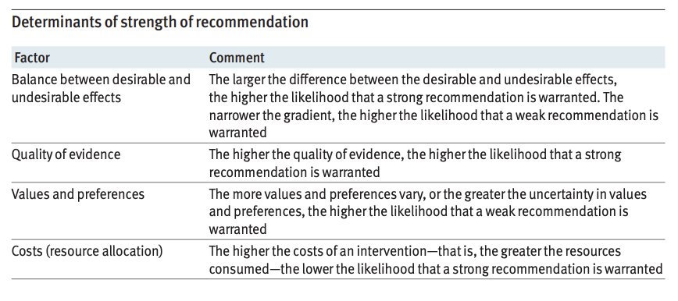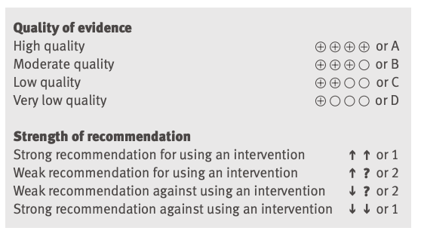

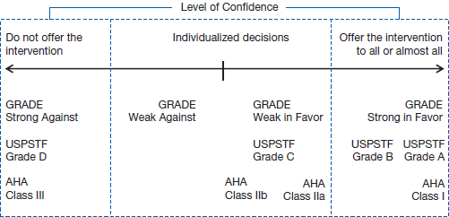

- Are there conflict of interest among participants? Consider both financial (binary, should uniformly be disclosed) and intellectual (more vaguely defined)
For example, intellectual conflicts of interest can be discrete (such as being an investigator on a trial related to the topic) or more sinister, such as in belonging to a profession that stands to benefit from recommendations (such as more aggressive recommendations from professional e.g. oncology/radiology guidelines vs USPSTF on mammography)

Note: COI are defined as any interest that could be perceived as a conflict to independence / objectivity. There is no requirement to demonstrate bias in action/views.

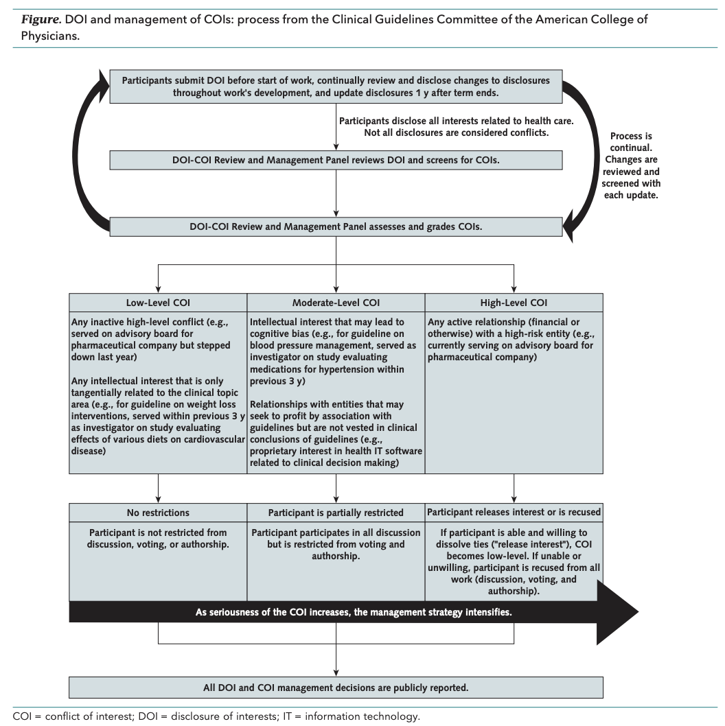
From: DOI: 10.7326/M18-3279 , deep dive in to how ACP manages COI in their guidelines.

- Did the committee make clear who guidelines apply to, the criteria used to make their assessment of strength of evidence vs strength of recommendation?

- Are the guidelines actionable? (E.g. “we recommend an interdisciplinary approach…”). For weak recommendations, do they give the right information to facilitate shared decision making? (ideally, a summary-of-findings table with absolute effect sizes)

- Did the recommendations touch on the major clinical issues within its scope? Is there sufficient data to make recommendations on those questions?

- How is a guideline different from a meta-analysis? (it incorporates preferences and values in order to make a recommendation) -> were they explicit on how different values and preferences were incorporated? (e.g. cost? Did they do a formal decision analysis – identifying the probabilities of outcomes with each decision strategy, then assigning a utility aka desirability to each of those outcomes)?

- Did they consider a full range of outcomes (morbidity/mortality, patient-centered outcomes (QOL, function), surrogate outcomes, cost?

- CPG were originally developed to support clinical decision making – they are often now used for a.) Institutional policy b.) Informing insurance coverage c.) medicolegal liability standards d.) Performance metrics (e.g. by payers). Are there problems with this guideline if it were used in those ways? E.g, is the level of evidence sufficient to support that?

- Are there additional considerations (such as more recent evidence or conflicting guidance from other sources) that make it difficult to know if this guideline should be trusted? https://doi.org/10.7326/M19-1941
