University of Utah Internal Medicine Journal Club Template:
Updated: Brian Locke 12/31/2019

COHORT STUDY FACILITATOR’S GUIDE

Cohort Study (Assigned Resident):
(Give 5-10 minutes for the following points):
- Goal: “Our aim [is] to distill an article down to its core while systematically reviewing its validity and telling a compelling story” Similar to case presentations, “the goal is to communicate the
- essential information [..] in a mostly standardized format that is easily digested by the listener”
“Improving journal club presentations, or, I can present that paper in under 10 minutes” DOI: 10.1136/ebm.12.3.66-a
- Cohort Study: An observational study where a group of individuals (the cohort) are followed after either being exposed (or not) to some factor of interest (e.g. a test, a treatment, an event). Cohort studies exploring prognosis may follow a well-defined population, with no explicit exposure.
- Article Title
- Study question: (prognosis, response to treatment, side effects from exposure/treatment? Why is this question important?)
- Retrospective or Prospective? (Could/should this have been investigated with another study design, e.g. RCT?)
- Patients included: (who is in the exposed group, and who is in the comparison group, if present? Were they enrolled early in the course of disease, aka inception cohort? Do they represent the underlying population? Where was the study done, if relevant?)
- Exposure of interest:
- If subgroups are different in ways that may influence the likelihood of the outcome (aka confounding), did the study authors adjust for this? How?
- Outcomes: (Especially primary outcomes. Blinded assessment? Objective? Appropriate duration of followup?)
- What are the Results? (including effect size, precision in the estimate. Loss to follow-up?)
- Critique: (Are there threats to the internal validity (such as bias, confounding, chance) or external validity, aka generalizability?)
- Can I apply the results to my patient? How?

Common discussion points for critiques of cohort studies:

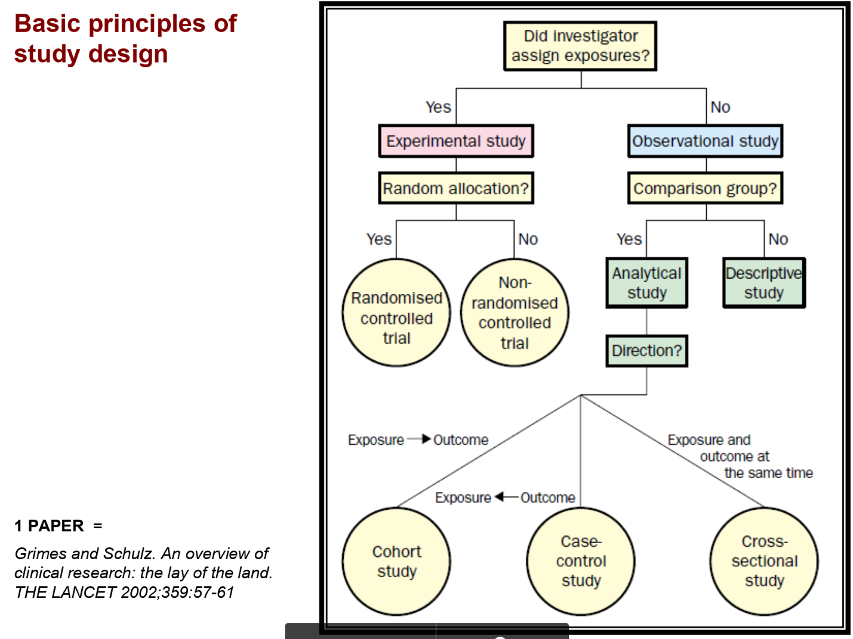

Could this have been an RCT? (Is there clinical equipoise? Funding issues? Logistics/timeframe issues?

What advantage does an RCT have over Cohort studies? (randomization controls for both known and unknown confounders, there is a well-defined entry point to the study which avoids ‘immortal-time bias’)
What is a confounder? What are some strategies to counter confounders in cohort studies? More info at:
https://www.ncbi.nlm.nih.gov/pubmed/18175191 and https://doi.org/10.1016/j.jclinepi.2020.01.021

Measured confounders: propensity matching (https://jamanetwork.com/journals/jama/fullarticle/2758936), multivariate analysis. Unmeasured confounders: negative control groups (https://www.ncbi.nlm.nih.gov/pmc/articles/PMC3053408/), instrumental variables (https://doi.org/10.1001/jama.2019.5646), computing an E-value (https://doi.org/10.1001/jama.2018.21554)

Why did the authors choose these statistical methods? (Ie. What was their goal in applying these statistical corrections?)

How is the finding of this paper manifested or presented in the guideline?

Generalizability: are there any major differences between the study population and our population (such as a health user bias?) from https://doi.org/10.7326/M19-1941
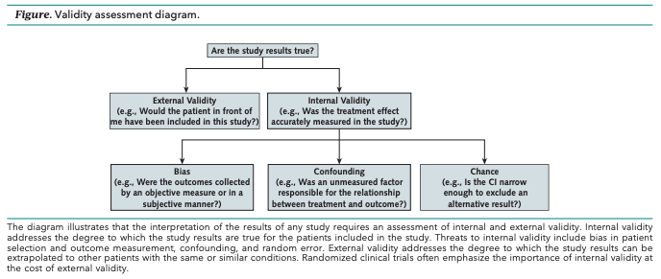

How strong is the treatment/exposure effect? How did they present this information? (Absolute vs relative) Did they perform any sensitivities analysis (to see how the result might change if variables were slightly different)?

Do they correctly interpret subgroup analyses, pre-specified vs post-hoc analyses (and why does that matter – because if you are able to look at the data to generate the research question, that same data cannot be used to answer it, thus post-hoc analyses are only exploratory and need confirmation in a separate study)?

